*Course title: Computer Graphics Lab*

*Course code: CSE-304*

*3rd Year 1st Semester Examination 2022*

**Date of Submission**: 28 May 2023



**Submitted to-**

**Dr. Mohammad Shorif Uddin**

*Professor*

**Dr. Morium Akter**

*Associate Professor*

*Department of Computer Science and Engineering*

*Jahangirnagar University*

*Savar, Dhaka-1342*

|  |  |  |  |
| --- | --- | --- | --- |
| **Sl** | Class Roll | Exam Roll | Name |
| 01 | 374 | 202186 | Mahfuz Anam |

**Source code (Point)**

#include<bits/stdc++.h>

#include<graphics.h>

using namespace std;

int main()

{

int x,y;

cout<<"Enter position: ";

cin>>x>>y;

int gd= DETECT,gm;

initgraph(&gd,&gm,"");

putpixel(x,y,WHITE);

getch();

closegraph();

return 0;

}

**Output:**

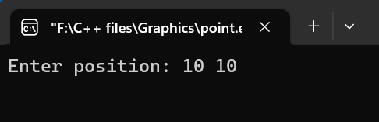 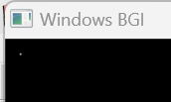

**Source code (DDA Line Algorithm)**

#include <graphics.h>

#include<bits/stdc++.h>

using namespace std;

void drawLineDDA(int x1, int y1, int x2, int y2) {

int dx = x2 - x1;

int dy = y2 - y1;

int steps = max(abs(dx), abs(dy));

float xIncrement = (float)(dx) / steps;

float yIncrement = (float)(dy) / steps;

float x = x1;

float y = y1;

for (int i = 0; i <= steps; ++i) {

putpixel(round(x), round(y), WHITE);

x += xIncrement;

y += yIncrement;

}

}

int main() {

int gd = DETECT, gm;

initgraph(&gd, &gm, "");

int x1, y1, x2, y2;

printf("Enter the starting point (x1, y1): ");

scanf("%d%d", &x1, &y1);

printf("Enter the ending point (x2, y2): ");

scanf("%d%d", &x2, &y2);

drawLineDDA(x1, y1, x2, y2);

getch();

closegraph();

return 0;

}

**Output:**

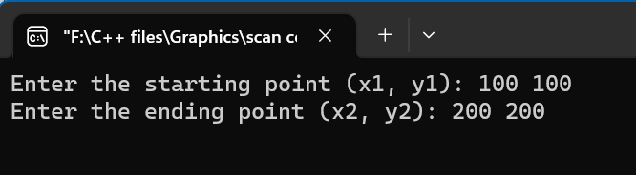

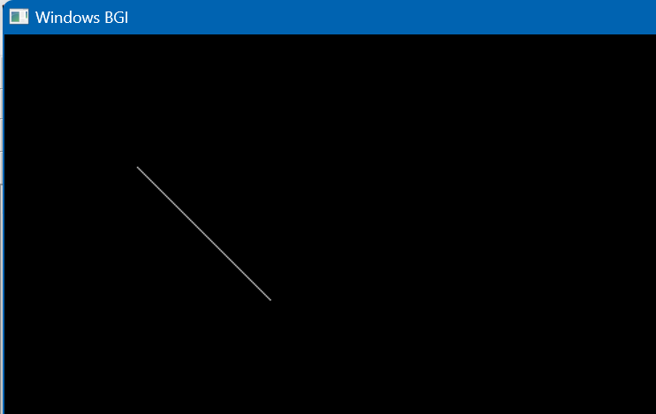

**Source code (Breshenham Line)**

#include <iostream>

#include <graphics.h>

using namespace std;

void LineBresenham(int x1, int y1, int x2, int y2)

{

int dx = abs(x2 - x1);

int dy = abs(y2 - y1);

int x, y;

if (x1 < x2)

{

x = x1;

y = y1;

}

else

{

x = x2;

y = y2;

x2 = x1;

y2 = y1;

}

int p = 2 * dy - dx;

putpixel(x, y, WHITE);

while (x < x2)

{

x++;

if (p < 0)

{

p += 2 * dy;

}

else

{

y++;

p += 2 * (dy - dx);

}

putpixel(x, y, WHITE);

}

}

int main()

{

int gd = DETECT, gm;

initgraph(&gd, &gm, "");

int x1, y1, x2, y2;

cout << "Enter the starting point (x1, y1): ";

cin >> x1 >> y1;

cout << "Enter the ending point (x2, y2): ";

cin >> x2 >> y2;

LineBresenham(x1, y1, x2, y2);

getch();

closegraph();

return 0;

}

**Output:**

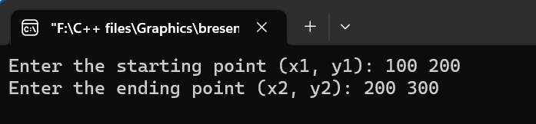

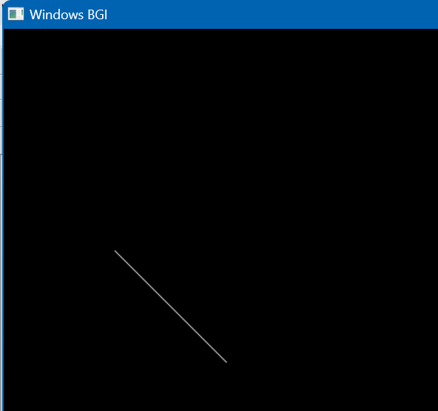

**Source code (**Breshenham Circle**)**

#include <iostream>

#include <graphics.h>

using namespace std;

void CircleBresenham(int xc, int yc, int radius) {

int x = 0;

int y = radius;

int d = 3 - 2 * radius;

while (x <= y) {

putpixel(xc + x, yc + y, WHITE);

putpixel(xc - x, yc + y, WHITE);

putpixel(xc + x, yc - y, WHITE);

putpixel(xc - x, yc - y, WHITE);

putpixel(xc + y, yc + x, WHITE);

putpixel(xc - y, yc + x, WHITE);

putpixel(xc + y, yc - x, WHITE);

putpixel(xc - y, yc - x, WHITE);

if (d < 0) {

d = d + 4 * x + 6;

} else {

d = d + 4 * (x - y) + 10;

y--;

}

x++;

}

}

int main() {

int gd = DETECT, gm;

initgraph(&gd, &gm, "");

int xc, yc, radius;

cout << "Enter the center coordinates (xc, yc): ";

cin >> xc >> yc;

cout << "Enter the radius of the circle: ";

cin >> radius;

CircleBresenham(xc, yc, radius);

getch();

closegraph();

return 0;

}

**Output:**

